
Lab no 03
COAL

Submitted to: Sir Imran
Submitted by: Wasif Ali (245187)
Date: 24/02/2026

Task 01:
Code:
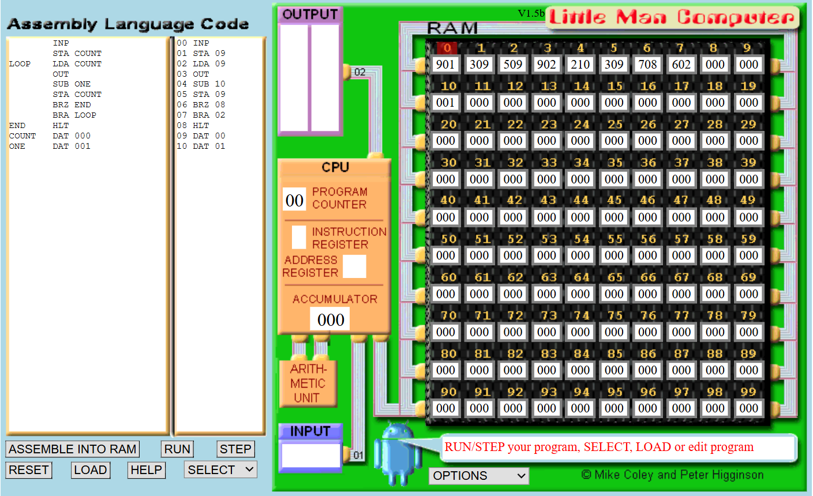
Result:
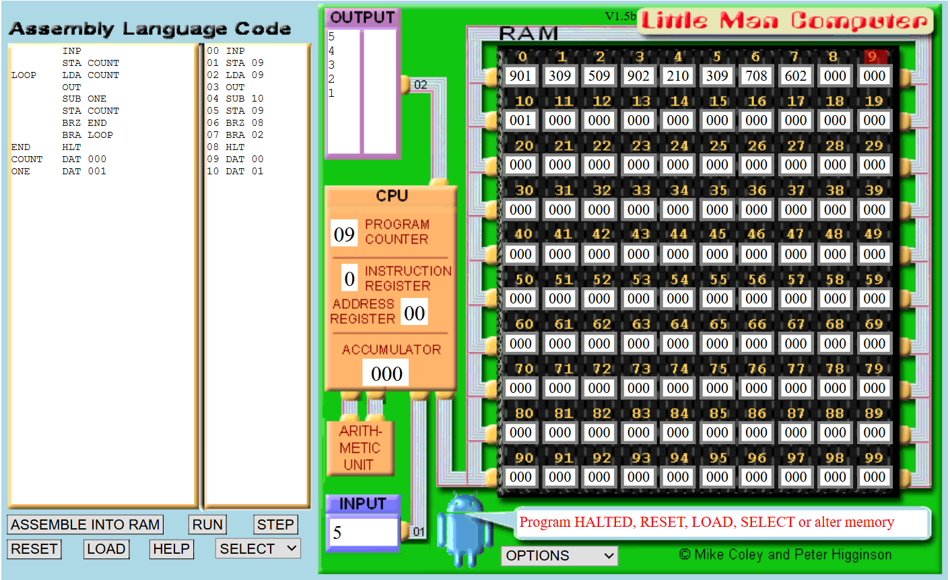
Step | Program Counter | Memory Address Register | Instruction Register | Accumulator
0 | 00 | --- | --- | 000
1 | 00 | 00 | INP | 000 → 5
2 | 01 | 01 | STA COUNT | 5
3 | 02 | 02 | LDA COUNT | 5
4 | 03 | 03 | OUT | 5
5 | 04 | 04 | SUB ONE | 5 - 1 = 4
6 | 05 | 05 | STA COUNT | 4
7 | 06 | 06 | BRZ END | 4 (not zero, skip)
8 | 07 | 07 | BRA LOOP | 4
9 | 02 | 02 | LDA COUNT | 4
10 | 03 | 03 | OUT | 4
11 | 04 | 04 | SUB ONE | 4 - 1 = 3
12 | 05 | 05 | STA COUNT | 3
13 | 06 | 06 | BRZ END | 3 (skip)
14 | 07 | 07 | BRA LOOP | 3
15 | 02 | 02 | LDA COUNT | 3
16 | 03 | 03 | OUT | 3
17 | 04 | 04 | SUB ONE | 2
18 | 05 | 05 | STA COUNT | 2
19 | 06 | 06 | BRZ END | 2 (skip)
20 | 07 | 07 | BRA LOOP | 2
21 | 02 | 02 | LDA COUNT | 2
22 | 03 | 03 | OUT | 2
23 | 04 | 04 | SUB ONE | 1
24 | 05 | 05 | STA COUNT | 1
25 | 06 | 06 | BRZ END | 1 (skip)
26 | 07 | 07 | BRA LOOP | 1
27 | 02 | 02 | LDA COUNT | 1
28 | 03 | 03 | OUT | 1
29 | 04 | 04 | SUB ONE | 0
30 | 05 | 05 | STA COUNT | 0
31 | 06 | 06 | BRZ END | 0 → jump
32 | 08 | 08 | HLT | 0
Task 02:
Code:
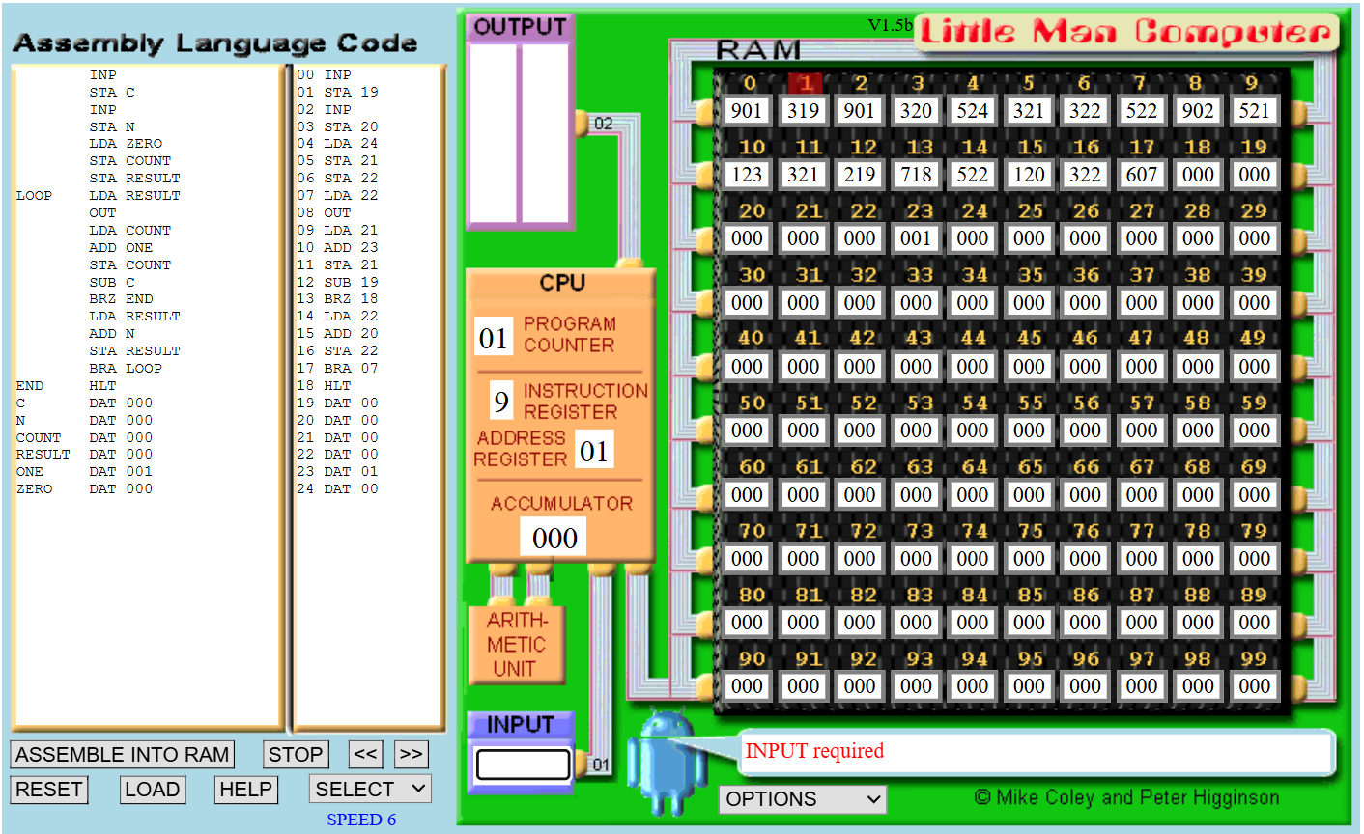
Result:
Input 1:
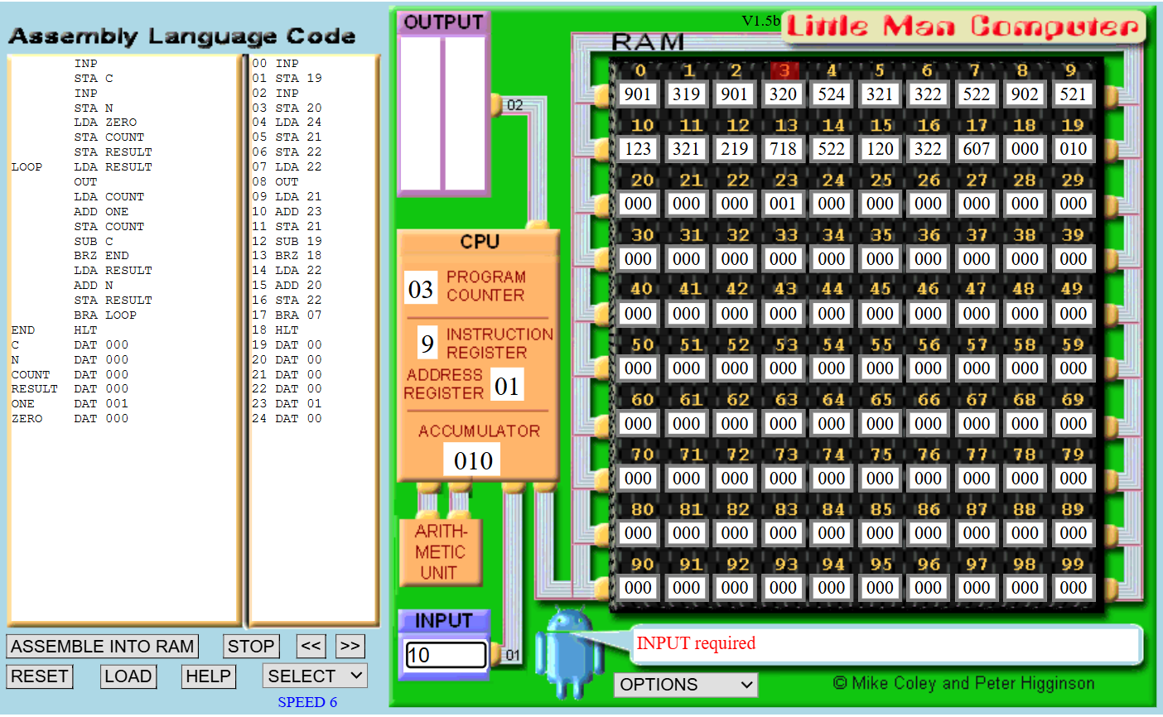
Input 2:
Running after second….
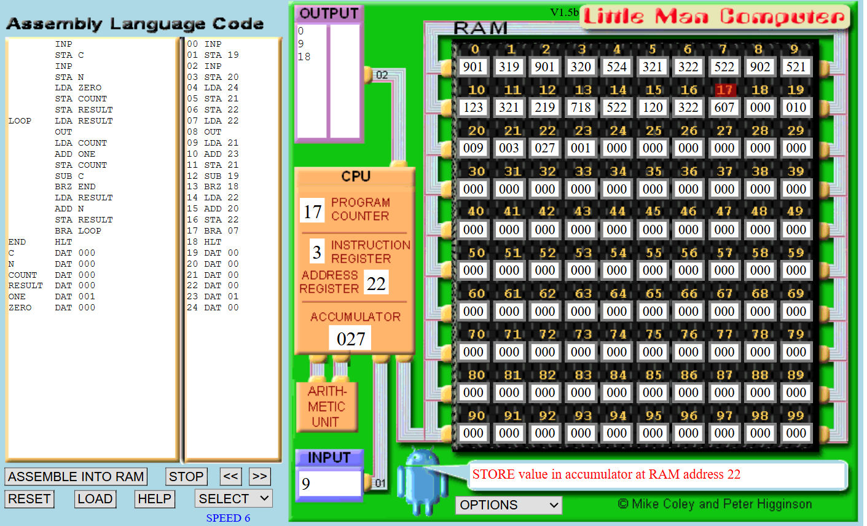
Final Result:
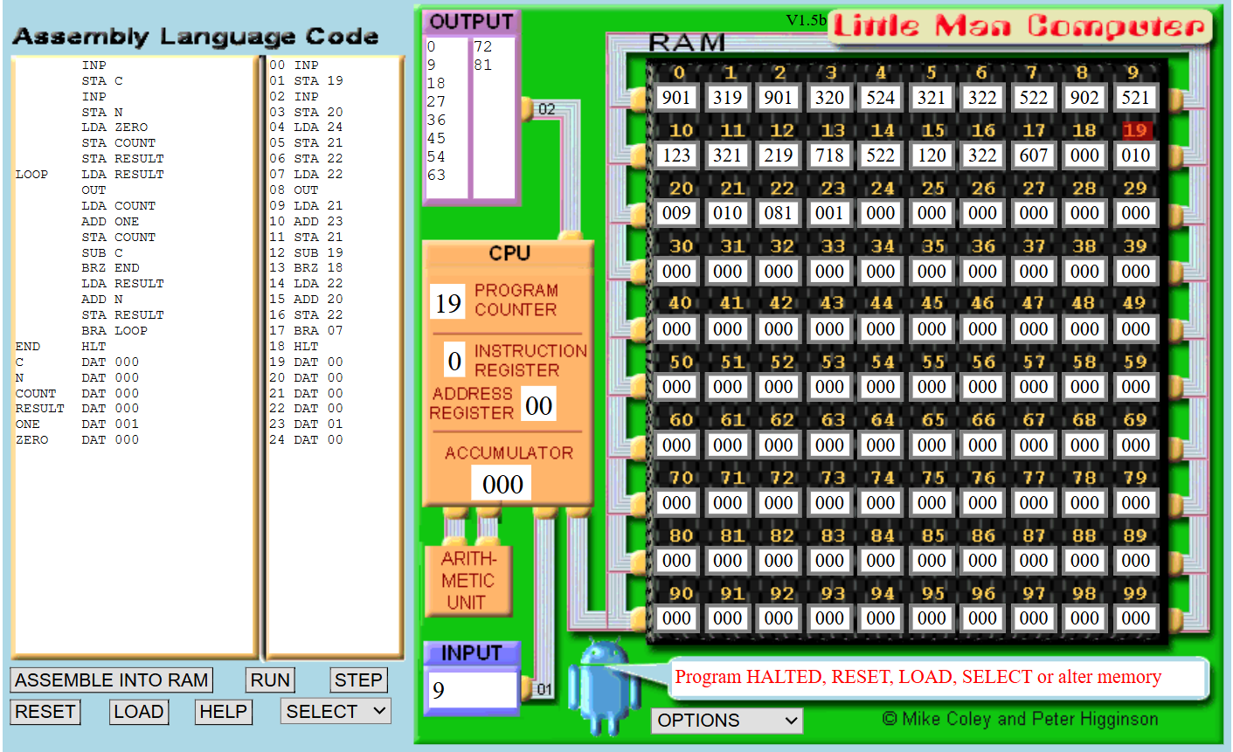
Task 03:
Code:
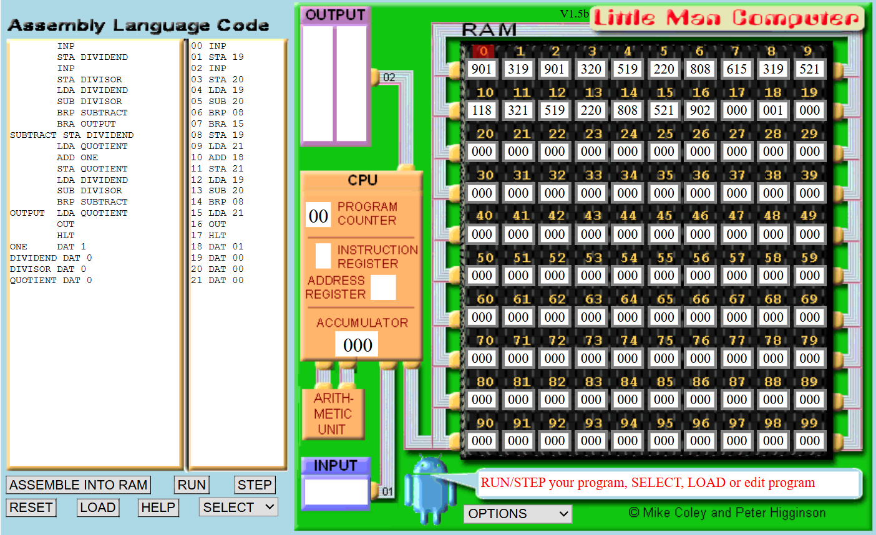
Result:
First input…...
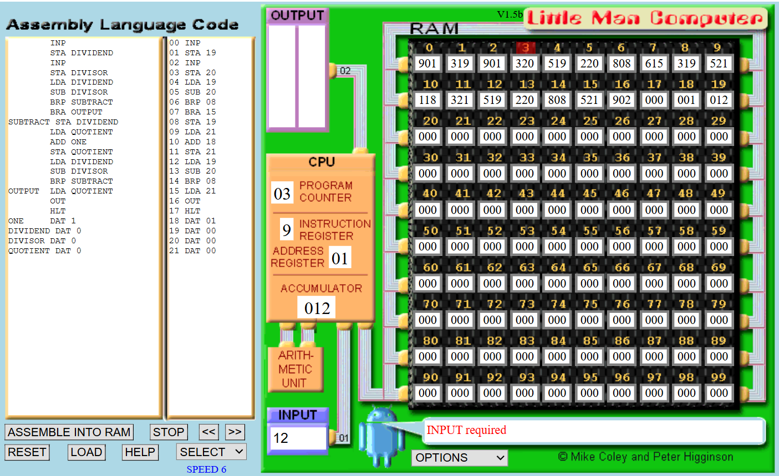
Second input….
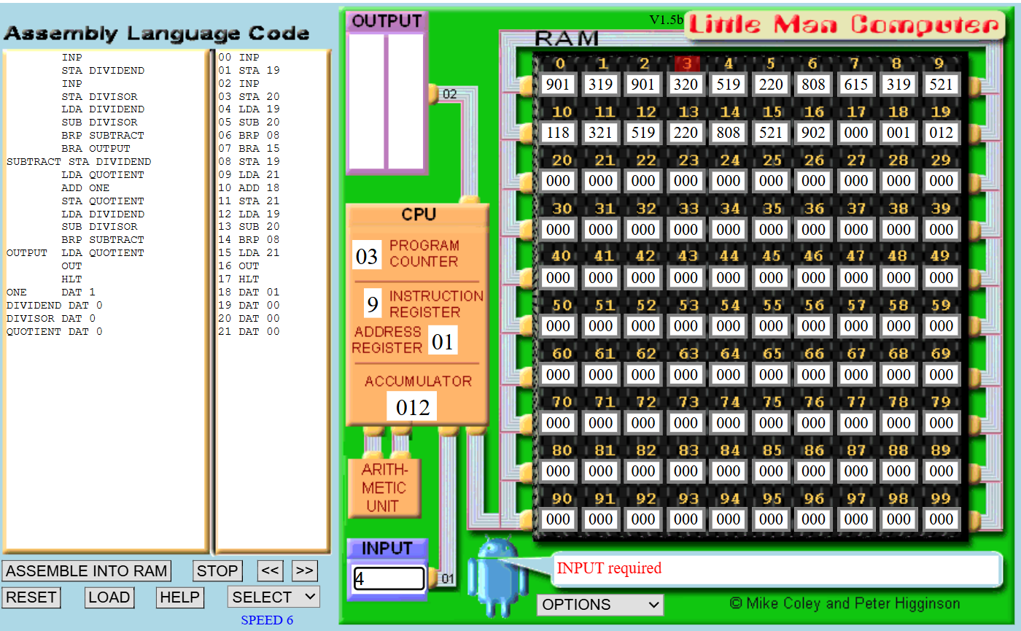
Final Result:
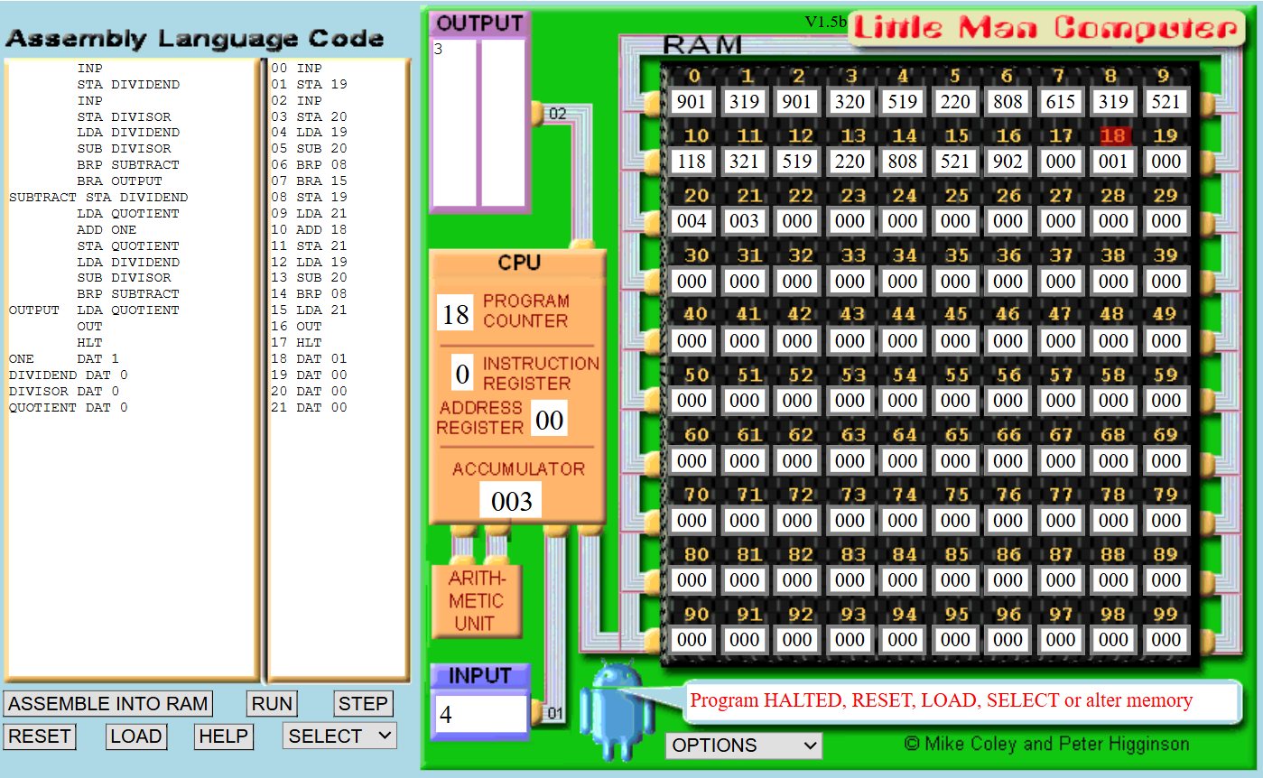
Task 04:
Code:
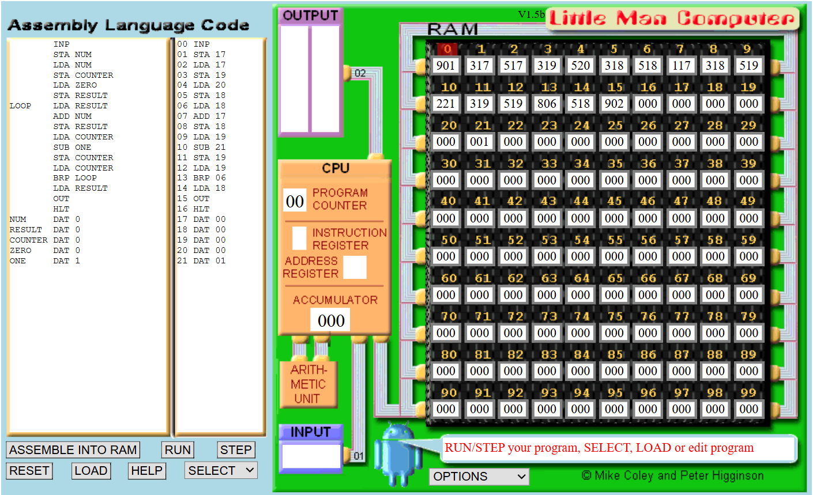
Result:
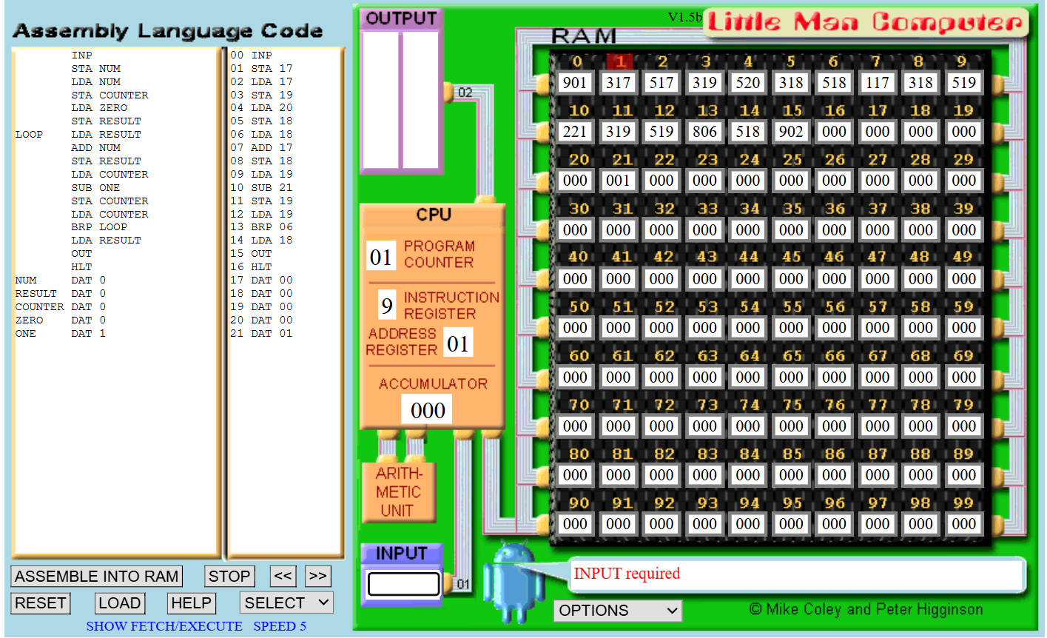
Final Result:
